

Managing the Smithgall Woods Website

User Guide

Prepared by The Woodland Rangers

UGA MBT Capstone Project

April 28, 2018

**Table of Contents**

Overview 2

Media 3-4

Add New Photos 4

Editing Pages 5-8

Editing Photos on a Page 5

Editing Text on a Page 6

Adding Photos/Text to a Page 6

Changing the slider on the home page 8

Appearance 8

Users 8

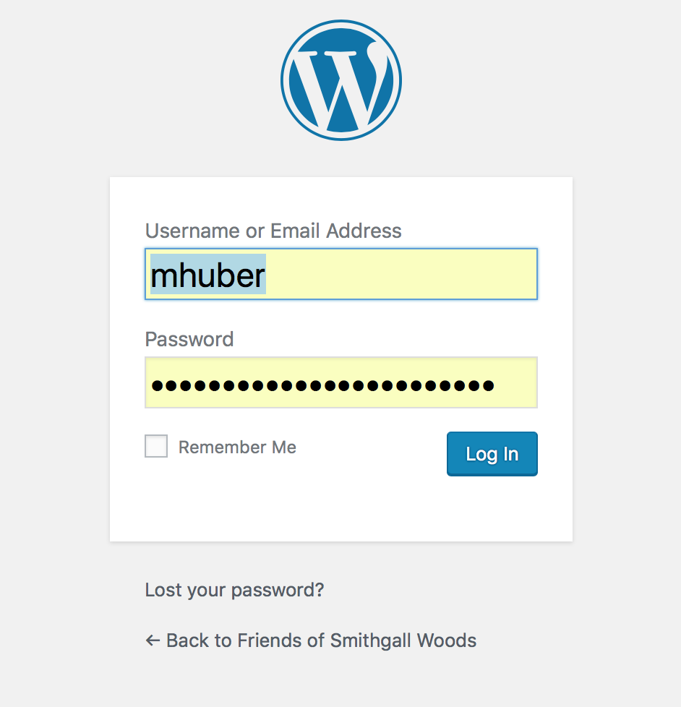The purpose of this document is to review the features, procedures and guidelines of maintaining the Smithgall Woods website, “[www.friendsofsmithgallwoods.org](http://www.friendsofsmithgallwoods.org)”. To begin this process, we will need to login to WordPress.

1. Log in at <https://www.friendsofsmithgallwoods.org/wp-admin/>
2. Check for updates to WordPress and Plugins. For full instructions, please use “Updating WordPress and Plugins” User Guide provided in your documentation packet.

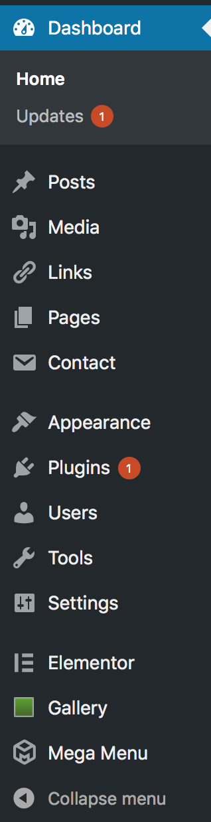

Here is an overview of the list of options on the left side of the screen.

* **Dashboard**: Gives a quick glance of our website. It will let us know if there is a new WordPress update available.
* **Posts**: We are not utilizing this feature for the website at this time.
* **Media**: This tab shows all photos uploaded for use on the website
* **Links**: This tab supplies technical information about WordPress. The information does not directly apply to our website
* **Pages**: This tab shows all of the pages of FriendsOfSmithgallWoods.com. This is where you will be able to access sections of the website to edit as needed. There is an “Add New” button below Pages that will allow you to add a new page if administration would like to highlight new features or events of Smithgall Woods. NOTE: If there is a dash at the beginning of the name, that means it falls under the category of name above it that does not have a dash. For example in this picture, About Smithgall Woods, Cottage Accommodations, Visitor Center, Directions, and Frequently Asked Questions all fall under the “Visitors” category on the website navigation menu. There will be more detail of this section, in the “Managing Pages” section later on in this guide.
* **Contact**: This is a form that allows a visitor to contact Smithgall Woods. This is not a highly used aspect of the website since users are more likely to email or call with questions.
* **Appearance**: This shows the current theme applied to our website. At the time of this publication, we have elected to use “Nature Bliss”. We will be going over how to customize, keep up to date, and change the themes later in this guide.
* **Plugins**: This section notifies you of possible updates for plugins installed. We recommend you update plugs in routinely, at least once a month. We go into further detail in the accompanying user guide “Updating WordPress and Plugins”.
* **Users:**  This allows you to create user accounts for individuals to help maintaining the website. We do not recommend creating too many users as this can increase the possibility of errors regarding content of the website. We recommend 2-3 users to have administrator access to FriendsOfSmithgallWoods.org
* **Tools:** We are not utilizing this feature for the website at this time.
* **Settings:** This has general settings of the website. We do not recommend changing any of these settings due to it might have adverse effects to the website.
* **Elementor:** For this particular tab of Elementor, we are will not utilizing this feature.
* **Gallery:** This tab provides tools to help manage the photos also under the media tab. You can give photos titles and descriptions, along with tags which are useful for visitors searching the website.
* **Mega Menu:** We are not utilizing this feature for the website at this time.

### **Media**

This tab actually has two sections: Library and Add New. Under Library, you have the option to edit existing photos, already uploaded for use on the website.

**Editing Photos**

Under Library, all photos uploaded for use on the website are present. By clicking on one of the thumbnails, a window will open and there are options to edit the clicked photo. At this point, you can give the photo a Title, Caption, Alternate Text, and Description. On the bottom right of the new window, you can click on “View attachment page.” You will be taken to a new page which will show you where the photo is being used in the website. If you click on “Edit more details”, this allows you to make the same adjustments you could also do under “Edit Image” on the previous page. On the previous page, if you were to click on “Edit Image”, a user can change the aspect ratio, give the photo new dimensions, and rotate the photo as needed. Once you make any changes, be sure to click “Save”. Also after clicking on the thumbnail of a photo, you can click “Delete Permanently” to remove the photo from the library. Here is an example of the options after clicking on the thumbnail of a photo:

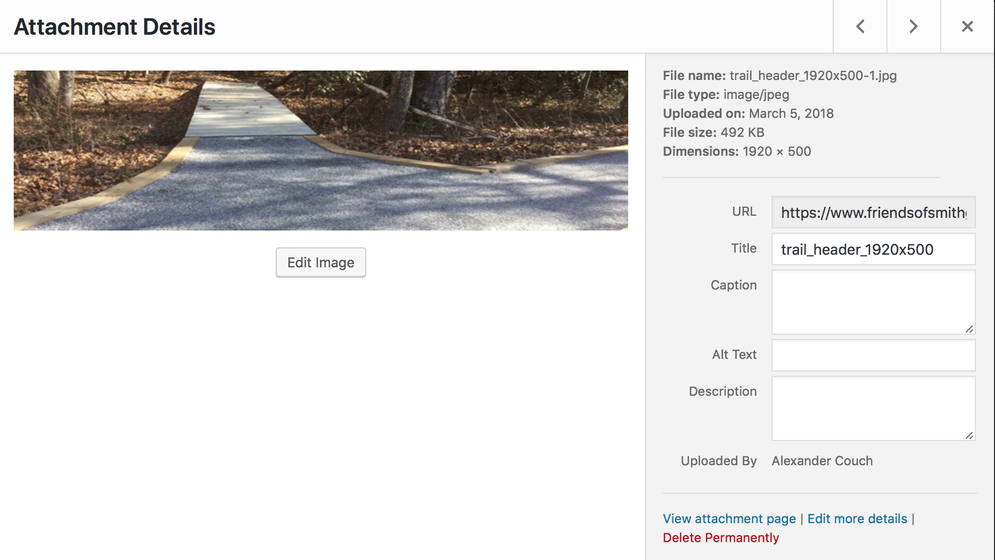

**Adding New Photos via Media Tab (Note this is the only option to upload photos for Roads & Trail page)**

To add new photos, click on “Add New” under Media. You have two options to upload photos. You can drag photos from a location on your computer to the “Drop files here” section. Or you can click “Select Files” and navigate to where your photos are located, select the photos you want to upload and then select “Choose”. This will upload photos to your site. Once the photo(s) are uploaded, the will appear below the avenues you have to upload photos. At this point you can click on “Edit” next to the uploaded photos to give the newly uploaded photos proper Captions, Alternative Text, and Descriptions. Once all of that information is input, be sure to click “Update” towards the top right of the page.

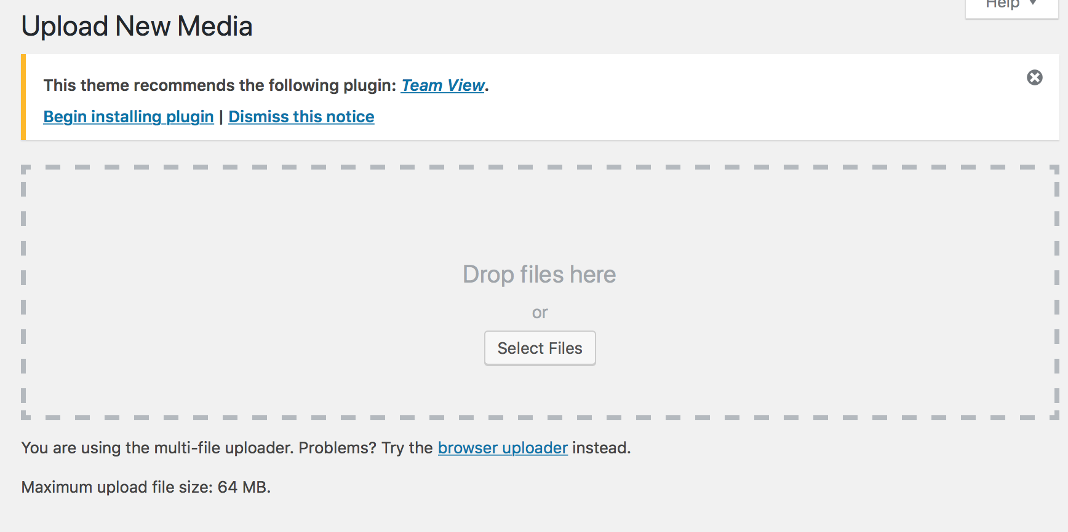

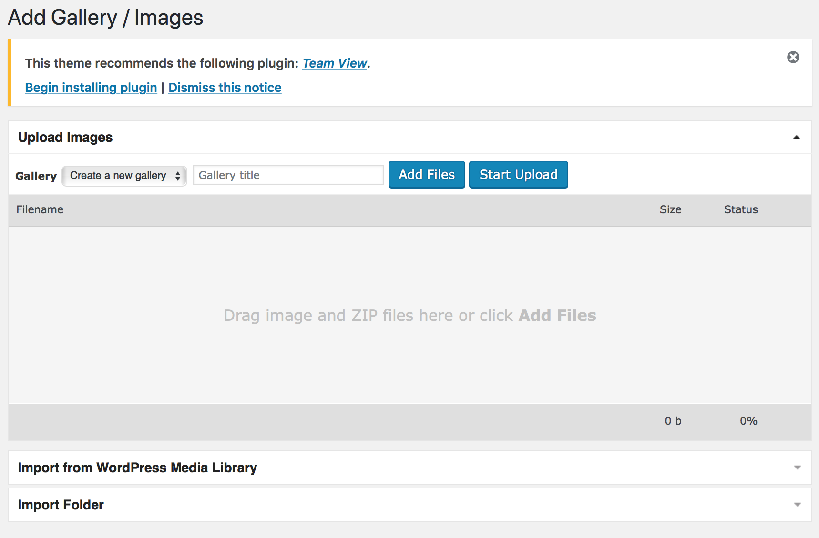**Adding New Photos via Gallery Tab**

Click on the Gallery Tab, then click “Add Gallery/Images” below Overview tab. Under “Upload Images” there is a drop down menu next to gallery, click on it and select “Smithgall Woods”. Now there are two options to upload photos to the gallery. Either you can drop photos into the dropzone or you can click on “Add Files”. “Add Files” allows you to navigate to where your photos are located, select the photos you want to upload and then select “Choose”.

### **Editing Existing Pages**

With the newest version of the website, we have installed a new tool to help making

Maintaining your website easier. The new tool is called Elementor. Here is a simple walkthrough updating a particular section of the website. While this walkthrough is for a specific page, the overall techniques and procedures are usable for all pages within the website. For this example we will be updating texts and photos for the section of the website, “Events”.

1. 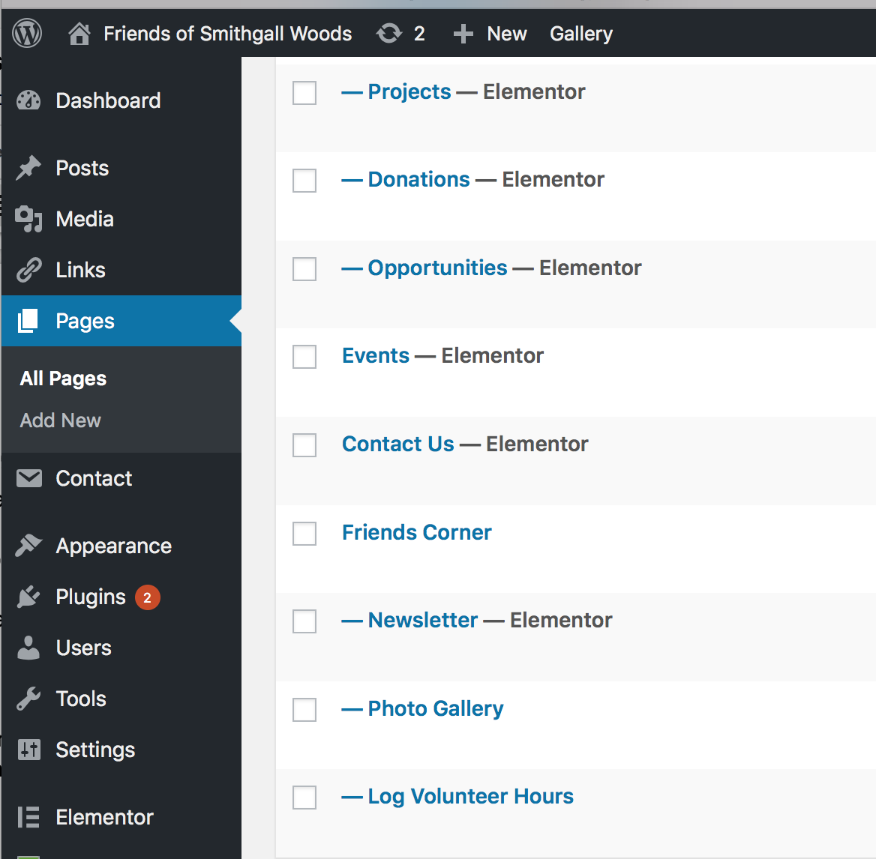Click on Pages on the side toolbar.
2. Scroll through the names until you find “Events”. In this case, Events was on the second page of available names.
3. Click on Events.
4. The page will refresh, now click on “Edit with Elementor” which is located middle of the page.
5. You will be taken to a new page, showcasing the “Events” as it is now, along with a new toolbar on the left hand of the screen. The Elementor toolbar allows you to add text, photos, video, sections, buttons, maps, and icons to your page.

**Editing a Photo on a Page**

1. For this example we are going to change the photo for “Volunteer’s Picnic”. To this we will hover our mouse over the picture associated with Volunteer’s Picnic. When we do that, this icon appears on the top right:
2. Click on the icon.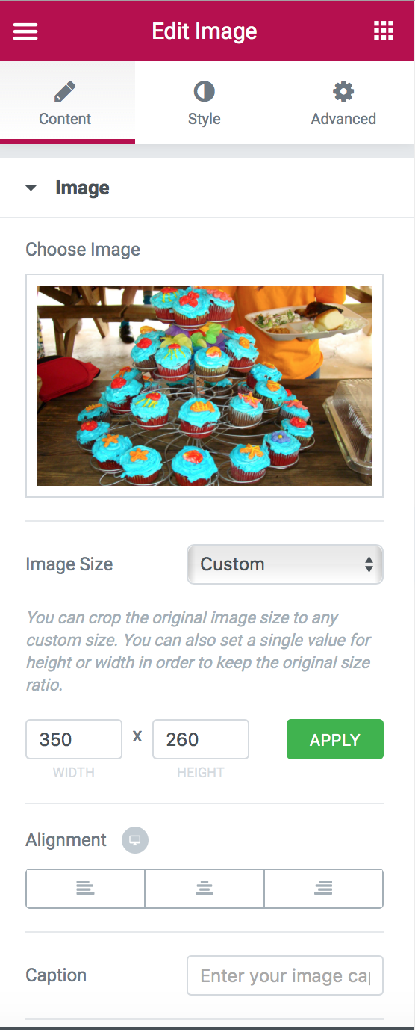
3. You will see to the left, the tool bar has updated to look like this:
4. Here you can change the dimensions of the picture to make the picture larger or smaller, you can align the photo to appear on the left, center, or right side of its respective section, you can add a caption to the photo, and you can change the photo.
5. To change the photo, click on the photo of the cupcakes. A box will pop with all of the photos you have in your gallery. To add photos to your gallery, please reference the previous section.
6. Click on the new photo you would like to be associated with Volunteer’s Picnic. You will see a check mark on the photo you select. Or you can upload the photo from your computer if you choose “Upload Files” at the top of the page. From there you can drag and drop your photos or click “Select Files” to navigate to the photos.
7. To the right of the dialog box you will see the option for “Insert Media”. Click on it.
8. You will be taken back to the page and see the photo for Volunteer’s picnic has changed.
9. On the toolbar on the left side of the screen you will see a button “Update”. You must click on this to finalize your changes to the page. If you make a mistake and accidently delete a section of your page, don’t worry! Simply refresh your page by going to the place where you type a website in on the top of your page, and hit enter. Your deleted section will be back.

**Editing Text on a Page**

1. For this example, we are going to edit the text for “Holiday Dinner” on the Events Page. To this, we simple hover our mouse over the section of text we want to edit, then we click anywhere in the section.
2. You will be able to start texting immediately.
3. Remove, edit, or add text as needed.
4. Once you make the change, you will need to click “Update” on the left side of the screen



This will save any changes you made to the text. Any saved changes will be immediately updated on your website.

**Adding Texts/Photos to a Page**

1. For this example, we will add a section to the Events Page. We are going to add an event “Fourth of July”. To start, at the bottom of the page you will see “Add New Section”. Click on it.

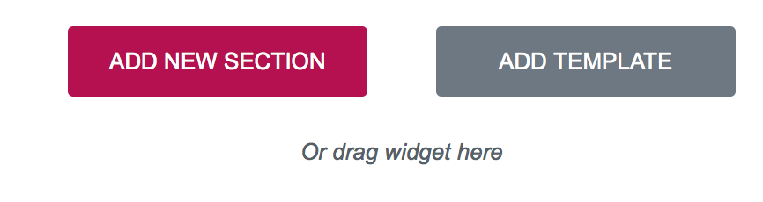

1. From there, you have a list possible “structures”. You can have one block, or you can divide it up into columns, much like a newspaper. Select a structure.
2. A dotted box will appear with a grey plus sign in the middle. Click on the plus sign.
3. On the left, a list of elements appear. These are things you can put into the dotted box on your page. For this example, we are duplicate the style of the other events on the page. Click on Image and drag it to the top of new section. A grey box will appear that says “Choose Your Image”
4. Click on “Choose Your Image”
5. On the left a smaller version of the grey box with “Choose Your Image” will appear
6. Click on the smaller version of “Choose Your Image”
7. A dialog box will appear of the photos you have in your gallery. Choose the desired photo, or you can upload the photo from your computer if you choose “Upload Files” at the top of the page. From there you can drag and drop your photos or click “Select Files” to navigate to the photos.
8. Select the photo you would like to add for the new Fourth of July section.
9. Then click on “Insert Media” on the bottom right.
10. You might notice that the photos is larger or smaller than the other photos on the page. For the Events page, photo sizes are 350 x 260. To change the size of a photo, click on the new photo and on the left side of the screen, you will see” Image Size”.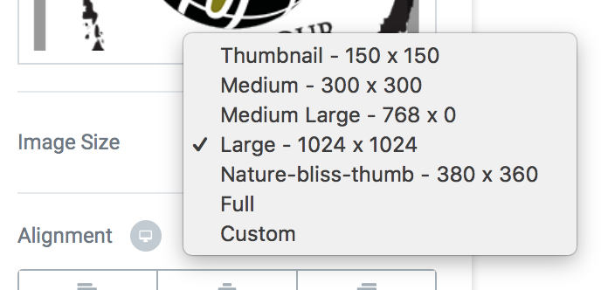
11. Click on the box next to “Image Size”
12. Then click “Custom”
13. Then for width type in 350, for height type 260 and then click “APPLY”. You will see the photo now is the same size of the other photos on the page. 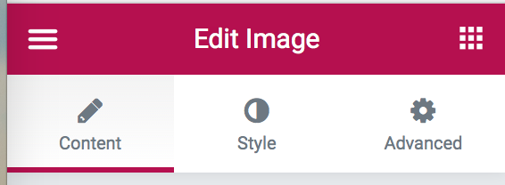
14. Now we need to add text. For this section to be inline with the rest of the page, we will add a section below the newly added photo. Click on the 9 mini boxes on the left of the page.
15. This will bring up the list of items you can add to your sections on the page. The Events page uses “Toggle”. Drag Toggle to below the new photo.
16. On the left side of the screen, hit the “x” next to Toggle #2. We only need one for this page.
17. Click on “Toggle #1”
18. You can give “Toggle #1” a name. Under “Title & Content”, erase Toggle #1 and type in “Fourth of July”
19. Now we need to edit the text. There are two ways to edit this text
    1. You can edit the text directly in the box, like we did in the “Editing Text on a Page” section above.
    2. You can edit the text in the toolbox on the left. Here you can change font sizes, bold, italicize, underline, create bulleted/numbered lists, and insert links to other webpages.
20. However you chose to edit your text, once completed and satisfied with how it looks, click on “Update” on the left.
21. Congrats you have just added a new section to the Events Page! Now apply these skills to other pages!

Elementor offers a lot of tools and layouts to really customize your webpages. There are a lot of possibilities to adding new content to your website. But be careful experimenting, if you feel that you have changed too many things, don’t click “Update” and simply refresh the page.

### **Updating the Slider on the Home Page**

From time to time the administration of Smithgall Woods might want to change the three sections of the slider on the home screen. This will be useful if they would like to showcase a new feature or an upcoming event at the park. Here is how to go about updating it: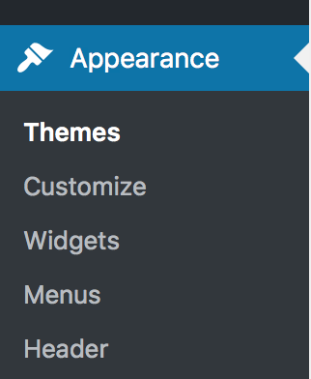

1. In WordPress, click on “Appearance” on the left side of the screen
2. Below that, click on “Customize”
3. A new page with appear. On the left side of the new screen, click on “Featured Slider”
4. The section of the screen will refresh, click on “Slider Type”
5. This section will again refresh. You now can pick and choose the three sections to be displayed on the slider on the homepage. Below “Feature Page-1”, “Feature Page-2”, “Feature Page-3” there is a drop down menu in which you can select with section you would like to showcase. At the time of this publication the three sections are: About Smithgall Woods, Friends Chapter, and Opportunities.
6. To finalize your selection, click on “Publish” on top left of the screen.

### **Appearance**

As of April 2018, the appearance of FriendsOfSmithgallWoods.org is Nature Bliss v1.0.2. Should the administration of Smithgall Woods decided to change the theme, here is a basic walkthrough to do so. It is the recommendation of the Woodland Rangers to use caution updating the theme. Updating to a different theme, might have adverse effects on the layout and functionality of the current theme. But should they still decide to update the theme here is a steps necessary to do so:

1. In WordPress, click on “Appearance” on the left side of the screen.
2. Then click on “Add New” on top of the page.
3. A list of possible theme will populate. Place your mouse of the graphic and then click on “Install”

While the walkthrough might seem simple, what is happening to your website is not. We do not recommend doing this without consulting someone familiar with WordPress and editing web pages.

### **Users**

This allows you to create user accounts for individuals to help maintaining the website. We do not recommend creating too many users as this can increase the possibility of errors regarding content of the website. We recommend only 2 or 3 users have administrator access to FriendsOfSmithgallWoods.org.

**To Add a New User**

1. In WordPress, click on Users on the left side of the screen.
2. Then click on “Add New” below “All Users
3. Assign the information prompted on the new screen. Assigned a role of Subscriber, Contributor, Author, Editor, or Administrator. Currently the only roles being used are Editor and Administrator.
4. Click “Add New User” on bottom of the screen to save the new user.

**To Delete a User**

1. In WordPress, click on Users on the left side of the screen.
2. Then click on “All Users” below “Users”
3. Hover your mouse over the user you would like to remove. Once you do that, three options will appear: Edit, Delete, View. Click “Delete”
4. You will be prompted to confirm deletion. Do so by clicking on “Confirm Deletion”

**To Edit Access for a User**

1. In WordPress, click on Users on the left side of the screen.
2. Then click on “All Users” below “Users”
3. Hover your mouse over the user you would like to edit. Once you do that, three options will appear: Edit, Delete, View. Click “Edit”.
4. You will see several options for the user. Update any section as needed. To specifically change their access to the site, scroll down until you see “Role”
5. Click on the drop down menu next to Role, and select the new level you would like to assign the user: Subscriber, Contributor, Author, Editor, Administrator, or No Role for this Site.
6. Now scroll to the very bottom of the page and click on “Update User”. This will save any changes you made to the user.